**EGERTON  UNIVERSITY**

Software Requirements Specification

for

Title: cereals board farmers portal

prepared by: MWARANGU MARTIN MWANGI

reg. no.: SP13/01596/15

project supervisor:dr phoebe ongalo

project cordinator:DR.-ING WILFRED .G. GIKARU

dates:16th november 2018

# version:1

Table of Contents

version:1 1

Table of Contents 2

Revision History 3

1.Introduction 4

1.1 Purpose 4

1.2 Document Conventions 4

1.3 Intended Audience and Reading Suggestions 4

1.4 Project Scope 4

2. Overall Description 5

2.1 Product Perspective 5

2.2. Product Features 5

Entity relation diagram showing how different modules interact 6

2.3 User Problem statement 8

2.4. User Objectives 8

2.5. Operating Environment 8

2.6. Design and Implementation Constraints 8

2.7. User Documentation 9

2.8. Assumptions and Dependencies 9

2.9. User Constraints 9

3.System Features 9

3.1. FARMER REGISTRATION and GROUPING FEATURE 9

3.2. RECORDS STORAGE 10

3.3. FARMER GRAINS DELIVERY 11

4. External Interface Requirements 11

4.1. User Interfaces 11

4.2. Hardware Interfaces 11

4.3. Software Interfaces 11

4.4. Communications Interfaces 12

5. Other Nonfunctional Requirements 13

5.1. Performance Requirements 13

5.2. Safety Requirement 13

5.3. Security Requirements 13

5.4. Software Quality Attributes 13

5.5. Other requirements Attributes 13

• Performance 13

• Reliability 14

• Availability 14

• Security 14

• Maintainability 14

• Portability 14

6. Preliminary Object-Oriented Domain Analysis 15

6.1. Inheritance relationships 15

6.2. User Classes and Characteristics 16

6.2.1 Class descriptions 17

7. Preliminary Budget and Schedule 18

SCHEDULE 19

8. Other Requirements 19

TECHNICAL SUPPORT 19

REMOTE DATA STORE FOR DATABASE BACKUP 19

8.1. References 20

8.2. Appendix A: Glossary of definitions, Acronyms and abbreviations 20

Appendix B: Analysis Models 20

Appendix C: Issues List 20

Revision History

|  |  |  |  |
| --- | --- | --- | --- |
| **Name** | **Date** | **Reason For Changes** | **Version** |
|  |  |  |  |
|  |  |  |  |

# 1.Introduction

## 1.1 Purpose

The purpose of this document is to describe the overall behavior and software requirements of a cereals board farmers portal. This SRS describes the quality assurance, operations, functional requirements and design constraints of a cereals board farmers system. It is meant to be used to maintain a shared understanding of the requirements between the developers and the clients of the system. This SRS captures the complete software requirements for the system and it is these requirements that will be used as guidelines in designing the cereals board farmers system.

## 1.2 Document Conventions

The document is written in the Calibri(body) font with a font size of 14 in the body and a font size of 14 as well on the cover page.

## 1.3 Intended Audience and Reading Suggestions

This document is intended for review by the various major stakeholders in the cereals farming industry. These stakeholders include :

* Officials at the agriculture ministry
* The directors at the NCPB
* Various farmers’ representation groups

This document is also intended for Any developer that will in future work on a cereals board system.

## 1.4 Project Scope

The cereals board farmers’ portal will seek to help streamline the process of registration and verification of farmers as well as storage of their records including grains delivered which will aid in keeping track of which farmer delivered what. This project will seek to help farmers get paid faster and prevent the board from being taken advantage of by third party traders.

# 2. Overall Description

## 2.1 Product Perspective

The Cereals Board Farmers Portal will be used in managing all records of cereal farmers across the country. The farmers will use their national ID card to be registered into the system this will be their unique user ID. The farmers will then be grouped under the umbrella of SACCOS based on their local areas which will enable simpler verification and tracking of individual farmers.

## 2.2. Product Features

At the heart of the product is the farmers registration system. The farmers will be required to present themselves at the local NCPB depot for registration the system will then pick their details and place them in SACCOS based on their local areas. The farmers records will feature their assigned SACCO, unique ID which will be their national ID number, farm number, farm location and an area to enter the grains received during delivery.

The system will also keep track of farmers grains in the silos through use of the SACCO where grains will be delivered under the SACCO and not by individual farmers and bags given a unique SACCO ID by the system that will be used to keep track of them and help in verification.

## 

Farmer

User name()

Id number()

Plot number()

Sacco name ()

Sacco

Sacco iso()

Sacco name()

Sacco area ()

Sacco email()

Grain Deliveries

Delivered amount()

Date delivered()

NCPB

Payments issued()

Grain reserves()

Deliveries received()

## Entity relation diagram showing how different modules interact

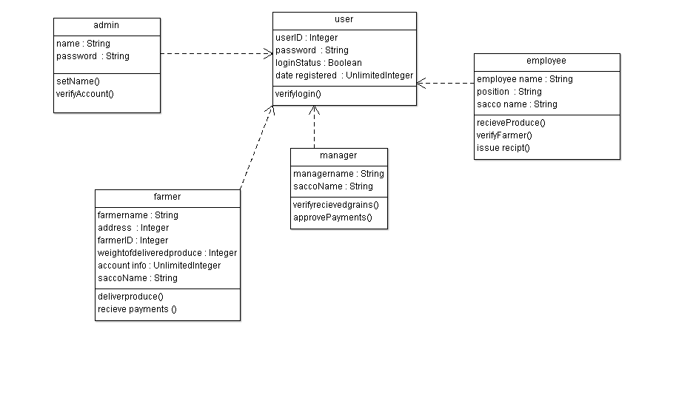

Class diagram

## 2.3 User Problem statement

There have been large delays in farmer payments that have rocked the NCPB recently. Farmers have had to wait for almost 6 months to get paid and even then not all of them have been able to. This has led to farmer disenfranchisement with some even selling their crops as animal feed. The biggest problem has been verification therefore a cereals board farmers portal needs to be developed to better aid in records keeping tracking and verification of farmers which will fast track their payments.

## 2.4. User Objectives

The main objective of the system is to streamline the keeping tracking and verification of records of genuine farmers in the country thus enabling them to receive payments quicker and deter those who try to take advantage of the current system in place

## 2.5. Operating Environment

The cereals board management system will be a web based system that will be accessible to all standard browsers. It will be compatible with all versions of windows from XP to all other later versions. The system will require my sql for the database.

## 2.6. Design and Implementation Constraints

Some of the design and implementation constraints might include :

* Internet connection since the system fetches data from the database over the internet therefore it is crucial for there to be internet connectivity
* Another constraint will be the capacity of the database since requests to the system can be made remotely from any part of the country the database might be forced to queue incoming requests which might increase the time it takes to fetch the data.

## 2.7. User Documentation

Cereals Board farmers portal proposal document . Alongside this a user manual will be provided to help users understand the working methodology proper usage and implementation of the system. The document will be written in non technical terms to cater to as wide a demographic of users as possible.

## 2.8. Assumptions and Dependencies

Some of the assumptions made include

* The users have a sufficient knowledge of computers
* Availability of comprehensive network coverage in most parts of the country.
* The operating system will have no problem working with third party software.

The dependencies that have so far been identified are :

* Access to reliable network
* An interface to the database.

## 2.9. User Constraints

The system will require the following features :

* A standard web browser that supports html css php etc
* It will make use of MYSQL for the data base
* It will also require a device with windows xp or later operating system with at least a storage of 2GB

# 3.System Features

## 3.1. FARMER REGISTRATION and GROUPING FEATURE

3.1.1 Description and Priority

The farmers details are received verified the farmer will be required to present their national ID and a signed document from the local area chief which will include farm location and land number which will be added onto the system. Once these details are verified the farmer is added to the system and added to a SACCO which will be used as an umbrella under which they deal with the board at a national level. This feature is of high priority in the system.

3.1.2 Stimulus/Response Sequences

The system will ask the user to add the following fields before registration farmer name, farmer id, farm number, farm location, once this fields are populated the system will then allow the user to register the verified farmer. Once registered the system will return a successfully registered message

3.1.3 Functional Requirements

MY SQL DATABSE MANAGER

WINDOWS OPERATING SYSTEM XP OR LATER

BROWSER THAT SUPPORTS HTML5 AND PHP

3.1.4 Technical Issues

The system might encounter some problems in areas with low internet bandwidth

3.1.5 Dependencies with other requirements

TBD

## 3.2. RECORDS STORAGE

3.2.1 Description and Priority

The verified farmers records need to be stored within the system for future use when the board will require them to process payments of farmers or to perform an audit. These records will be grouped according to the newly generated SACCOS. It will allow the system admin to query the system and find a detailed view of the records kept. This feature as well is of high priority.

3.2.2 Stimulus/Response Sequences

This feature allows the users to view records that have been kept within the system and find specific records appertaining to individual farmers or SACCOS

3.2.3 Functional Requirements

The requirements include

* MY SQL DATABSE MANAGER
* WINDOWS OPERATING SYSTEM XP OR LATER

3.2.4 Technical Issues

The system might encounter some problems in areas with low internet bandwidth

3.2.5 Dependencies with other requirements

The system dependencies include access to mysql database as well as access to stable network .

## 3.3. FARMER GRAINS DELIVERY

3.3.1 Description and Priority

Farmers will eventually be required to deliver grains at their local SACCO which will then be delivered to the board . The grains delivered will be added to the farmers records and a receipt to verify delivery has occurred is issued a copy of which is stored in the system .

3.3.2 Stimulus/Response Sequences

This feature allows the sacco employee to input the details of the grain delivery by the farmer i.e number of bags and type of grains as well as determine which verified farmer delivers the grains then forward this delivery to the NCPB

3.3.3 Functional Requirements

The requirements include

* MY SQL DATABSE MANAGER
* WINDOWS OPERATING SYSTEM XP OR LATER

3.3.4 Technical Issues

The system might encounter some problems in areas with low internet bandwidth

3.3.5 Dependencies with other requirements

The system dependencies include access to mysql database as well as access to stable network .

# 4. External Interface Requirements

## 4.1. User Interfaces

The system should be user friendly and have features that are easy to locate with a clearly defined functionality.

## 4.2. Hardware Interfaces

TBD

## 4.3. Software Interfaces

Some of the software interfaces required include:

* A CMS external interface which is expected to be developed by the developers team and should provide read only access to all the CMS data. In a special case, if an additional data is required a special request needs to be made to the development team staff . This can lead to delays in delivery of the project

## 4.4. Communications Interfaces

The cereal board farmers portal is a web based system and therefore will make use of standard web browsers example Mozilla Firefox.

# 5. Other Nonfunctional Requirements

## 5.1. Performance Requirements

TBD

## 5.2. Safety Requirement

* During implementation ergonomics has to be seriously considered to ensure the long term health of the users as making use of the system could require the users to be seated behind a computer for most of the day.
* System should be designed to have an interface that is clear as possible with acceptable contrasts of colours and with a font that is easy on the eye. This will prevent straining which could lead to users developing eye problems.

## 5.3. Security Requirements

* Only a select group of people with authenticated login credentials are able to perform both read and write operations on the records stored in the system
* Users will have multiple roles which will limit how much of the system a user can access according to their set level
* Database backup will be done regularly in order to ensure the safety of the records

## 5.4. Software Quality Attributes

The system will be easy to use and help speed up the process of verification of farmers . By providing clear and accessible records it will also be of use whenever an audit of the payments made by the board as well as one of storage records is done.

## 5.5. Other requirements Attributes

### Performance

The system shall run on ordinary desktop computers with windows XP or later version installed with minimal requirement s without any problems

### Reliability

The system is reliable and will not create errors while running.

### Availability

The system will be available to users as long as there is power and they have an access to a network.

### Security

System will use secured database. Normal users can just read information but they cannot edit or modify anything .

### Maintainability

The system requires minimal maintenance as it is simple.

### Portability

The system is portable as it is accessible from various web browsers.

# 6. Preliminary Object-Oriented Domain Analysis

This section presents a list of the fundamental objects that must be modeled within the system to satisfy its requirements. The purpose is to provide an alternative ‘structural’ view on the requirements stated above and how they might be satisfied in the system.

## 6.1. Inheritance relationships

Use case diagram 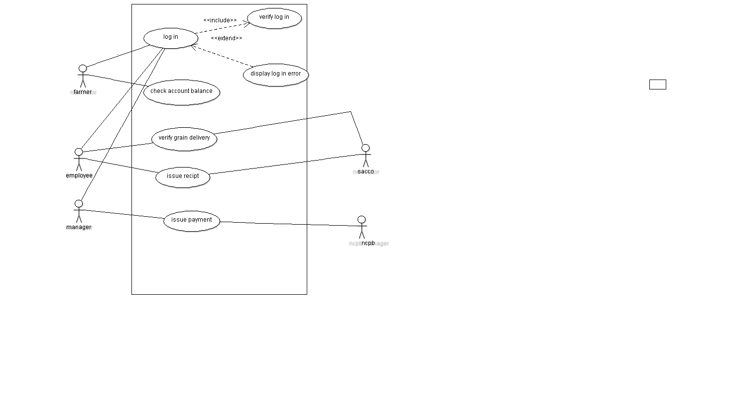

## 6.2. User Classes and Characteristics

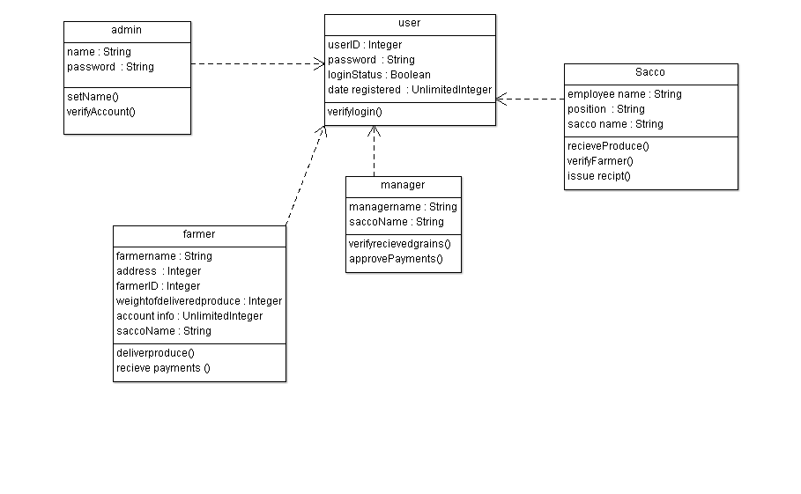



Class diagram (how each user interacts with the portal)

6.2.1 Class descriptions  
This section presents a more detailed description of each class identified during the OO Domain Analysis. For more details on the process giving rise to these descriptions, see [Lecture 5.3: OO Domain Analysis](http://goanna.cs.rmit.edu.au/%7Elinpa/SE/Srs/Templates/5.3.html) and/or texts on object-oriented software development.

Each class description should conform to the following structure:

**6.2.1.1 <Class name>**

**6.2.1.1.1 Abstract or Concrete:**   
Indicates whether this class is abstract or concrete.

**6.2.1.1.2 List of Superclasses:**

* ADMIN
* MANAGER
* SACCO

**6.2.1.1.3 List of Subclasses:**   
ADMIN MODULE:

* Users
* Information
* Account Verification
* Farmer records

MANAGER MODULE:

* Managers
* Information
* Approval of payments
* Farmers records

SACCO

* Farmers records in the specific SACCO
* Grains delivered by farmer on day/date
* Grains delivered to ncpb day/date
* Verify farmers

# 7. Preliminary Budget and Schedule

**BUDGET**

|  |  |
| --- | --- |
| **RESOURCE** | **ESTIMATED COST(KSHS)** |
| Development team salary | **70000** |
| Questionnaire | **1200** |
| Network Connection | **5000** |
| Travel | **1200** |
| Testing | **1000** |
| Hardware resources | **60000** |
| **TOTAL** | **138400** |

# SCHEDULE

|  |  |  |  |  |  |  |  |  |  |  |  |  |  |  |  |  |  |  |  |  |  |  |  |  |  |  |  |  |
| --- | --- | --- | --- | --- | --- | --- | --- | --- | --- | --- | --- | --- | --- | --- | --- | --- | --- | --- | --- | --- | --- | --- | --- | --- | --- | --- | --- | --- |
| Week | 1 | | | 2 | | 3 | 4 | 5 | 6 | | | | 7 | | | | 8 | | | 9 | | | | 10 | | 11 | | |
| Documentation | Project proposal | | | |  | |  |  |  | | | |  | | | |  | | |  | | | |  | |  | | |
|  | |  | | Software Requirement specification | | |  |  | | | |  | | | |  | | |  | | | |  | |  | | |
|  | |  | |  | |  | Software design description | | | | | | |  | |  | | |  | | | |  | |  | | |
|  | |  | |  | |  |  | | | | Test plan | | | | | |  | | |  | | |  | | |
|  | |  | |  | |  |  | | | |  | |  | | | manual | | | | |  | |  | |  | | |
|  |
|  |
|  |  | |  | |  | |  |  | |  |  | | | | |  | | |  | | | |  | |  | | |
| Project implementation |  | |  | |  | |  |  | |  |  | | | | |  | | |  | | | |  | |  | | |
|  | |  | |  | |  |  | |  |  | | | | |  | | |  | | | |  | |  | | |
|  | |  | |  | |  |  | |  |  | | | | |  | | |  | | | |  | |  | | |

# 8. Other Requirements

## TECHNICAL SUPPORT

System developers will have access to the system source code which will help them in recognizing and dealing with any bugs that might occur within the system.

The database managers should be able to provide on site support in case issues arise in the database

## REMOTE DATA STORE FOR DATABASE BACKUP

A remote data store where backup to what is stored in the database is necessary incase of any failures this data store should be accessible online and work in real time with the main database for features such as updates

# 8.1. References

# 8.2. Appendix A: Glossary of definitions, Acronyms and abbreviations

<Define all the terms necessary to properly interpret the SRS, including acronyms and abbreviations. You may wish to build a separate glossary that spans multiple projects or the entire organization, and just include terms specific to a single project in each SRS.>

Appendix B: Analysis Models

<Optionally, include any pertinent analysis models, such as data flow diagrams, class diagrams, state-transition diagrams, or entity-relationship diagrams.>

Appendix C: Issues List

< This is a dynamic list of the open requirements issues that remain to be resolved, including TBDs, pending decisions, information that is needed, conflicts awaiting resolution, and the like.>